#### 

#### 

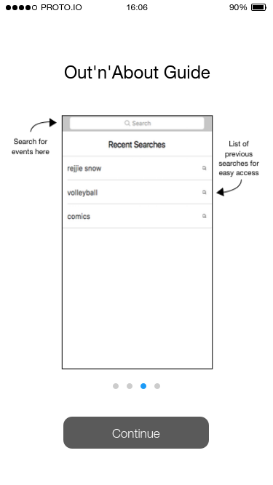

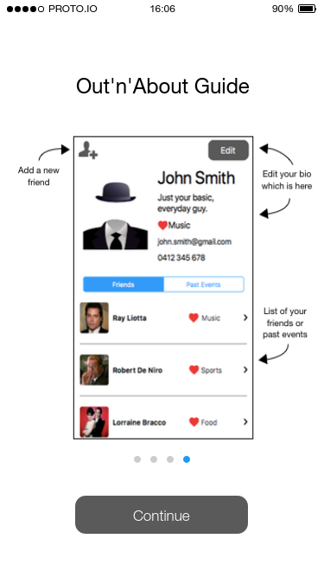

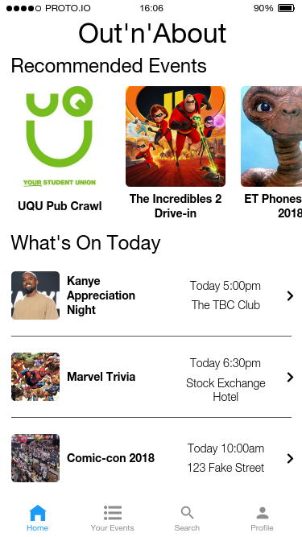

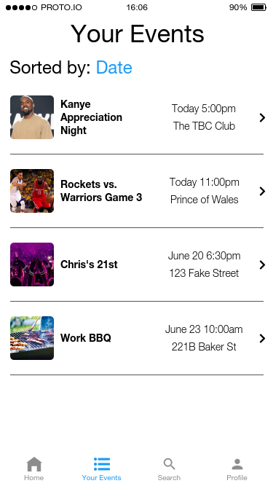

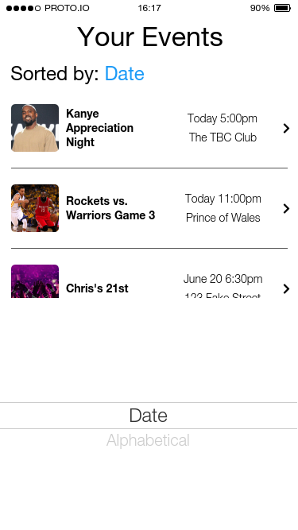

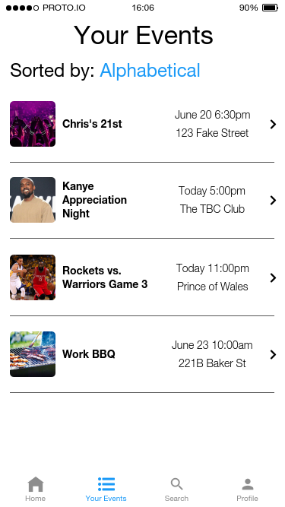

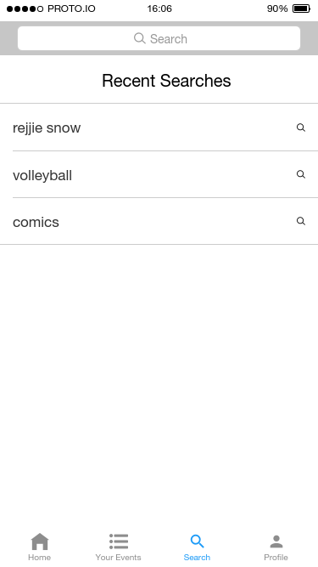

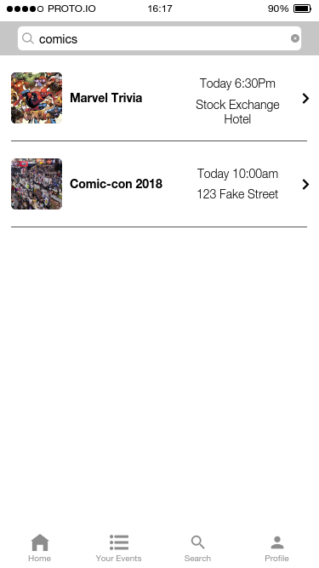

#### Profile

|  |  |
| --- | --- |
| *Profile w/ Friends* | *Profile Ready to be Edited (tap fields to modify)* |
| *Profile w/ Past Events* | *Friend Search (from pressing top left add button on profile)* |

#### Miscellaneous

|  |  |
| --- | --- |
| *Example of a Friend Page* | *Example of an Event Page* |